POWER BI :

AIMS Grid :P

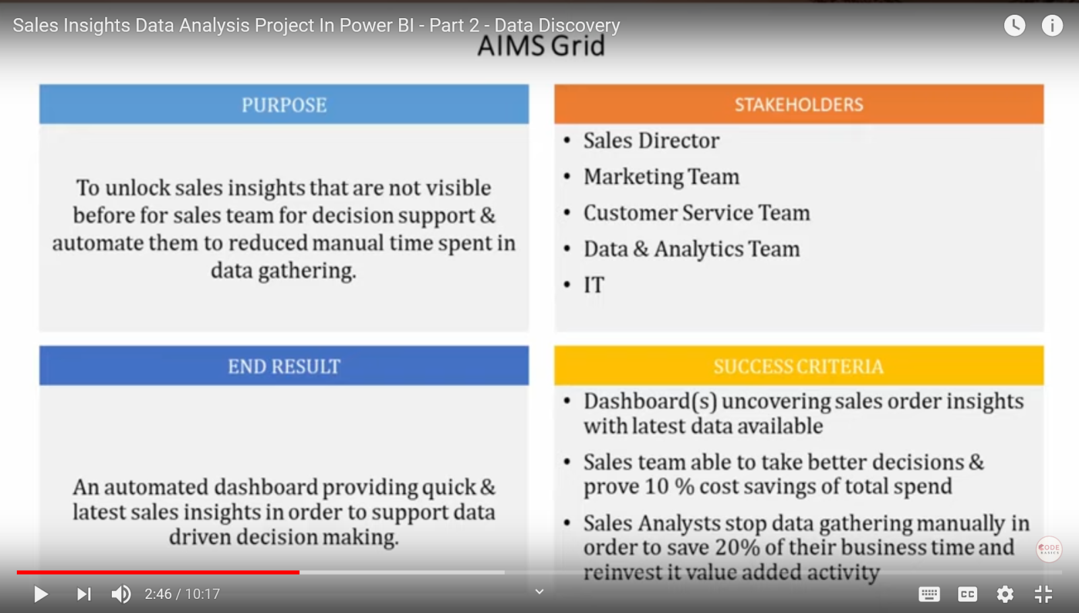

OLTP : (https://database.guide/what-is-oltp/)

OLTP (Online Transactional Processing) is a category of data processing that is focused on transaction-oriented tasks. OLTP typically involves inserting, updating, and/or deleting small amounts of data in a database.

OLTP mainly deals with large numbers of transactions by a large number of users.

**OLAp VS OLTP:**

<https://www.stitchdata.com/resources/oltp-vs-olap/>

* Data Munging/ Data Wrangling
* ETL (Extract, Transform & LOAD)

https://community.powerbi.com/t5/Desktop/How-to-remove-columns-with-NA-or-columns-of-a-certain-type-in/td-p/50446

STAR SCHEMA:

